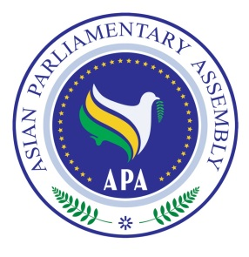
Asian Parliamentary Assembly
The 11th Plenary Session

Meeting of
Standing Committee on Budget & Planning

30 November 2018
Istanbul – Turkey

Draft Agenda
1- Adoption of the Agenda
2- Election of the Bureau
3- Opening Remarks by Chairperson of the Meeting
4- Deliberation on the report of APA Secretariat approach to the Member Parliaments on Model of Payment of Assessed Contribution
5 - Consideration of Draft Resolutions recommended by the Executive Council
6- Any other matters.

As of 27 November 2018

